API Security-2

1. Install and configure Burp Suite

Installed and configured

2. Change response message of buy course API

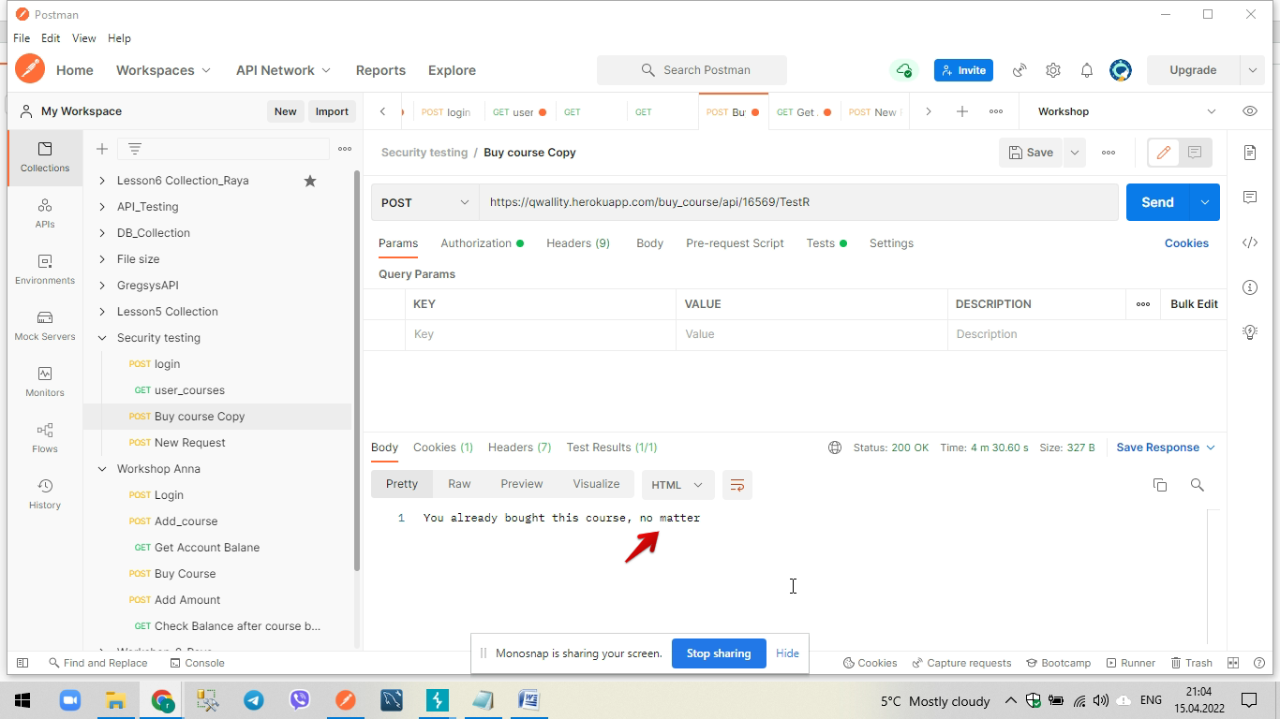

3. Try to guess adminuser password

